**Focus Keyword: Types of Fades**

**Meta Title: Types of Fades | Educatecast**

**Meta Description: A fade is a taper that progressively brings the hair down to the skin giving an appearance of fade hairline.**

**Feature Image**

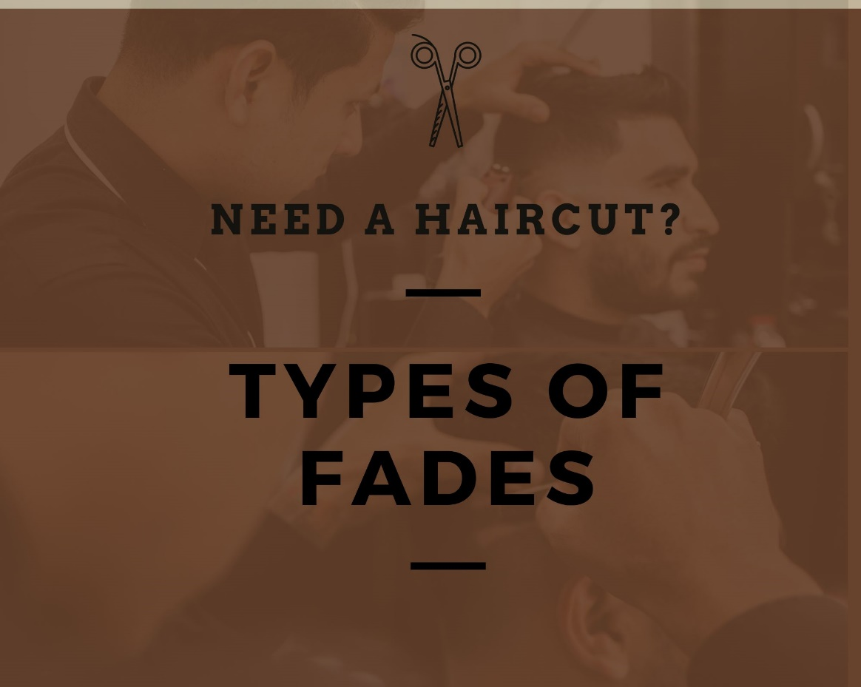

**Types of Fades**

**Fade**

**“A fade is a taper that progressively brings the hair down to the skin, giving the appearance that the hairline on the sides and back of your head "fades" before reaching the natural hairline.”**

**History of Fades**

The haircut first appeared in the **United States military** in the **1940s and 1950s**. Given the military's high grooming requirements, it's no wonder that the fade haircut was and continues to be popular among military men, since the severe lines and angles signified you meant business.

Throughout the years, Black people have experimented with many hairstyles, such as the afro and the notorious Jheri curl. By the mid-1980s, a **redesigned, edgier version** of the fade was appearing, due to **Black barbers.** During the golden age of **hip-hop culture**, it quickly became a standard.

**Who came up with the fade hairstyle?**

**Larry Blackmon,** the main vocalist of the band Cameo, was commonly attributed with the hairstyle in the mid- to late 1980s. In the mid-1980s, Blackmon wore a haircut similar to the hi-top Fade, with the tall square flat top but significantly longer sides and back.

**"Hip-hop** influenced the way we dressed, especially how we wore our hair," says **Greg Cooper Spencer,** a New York-based master barber and hairdresser with more than 20 years of expertise.

"As hip-hop arose, so did the musicians who made their hair and clothing stand out, alongside their music," **Spencer** says.

We're discussing the **hi-top fade**, often known as the flattop. **Grace Jones** wore one on her 1980 Warm Leatherette album cover before Cameo, Big Daddy Kane, Eric B & Rakim, and others made it their hallmark style. Many think Queen Nefertiti's crown originated in Ancient Egypt because it closely resembles the hi-top.

Trends come and go, with the hi-top disappearing in the early 1990s. With the exception of Black superstars such as Nas, Kanye West, Usher, will.i.am., and Kendrick Lamar who modernized it in the 2010s, the hi-top has gradually developed back into a more tapered style similar to how it began.

**Types of fades**

A fade haircut is one of the most attractive methods to update your hairstyle. There are many various sorts of fades, so everyone may choose one that suits their interests and needs. Long hair on top is matched by various fade haircuts for men, low, mid, and high, depending on the amount of boldness you want to accomplish. So, don't put off choosing the ideal fade hair cut for yourself any longer.

**The Seven Major Fade Types:**

1. Drop fades

2. Scissors Fade

3. Temple fade

4. Low fade

5. Skin Fade

6. Bald fade

7. Burst Fade

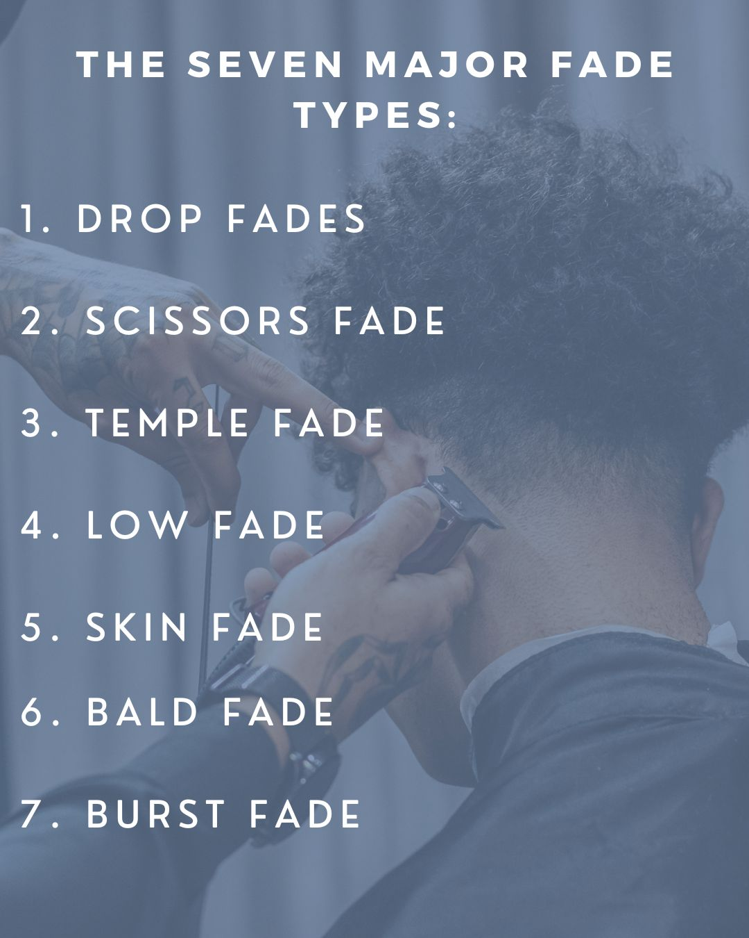

1. **Drop fade**

Drop fades might begin high, medium, or low, but they always have one feature; the fade line at the rear of the head is pulled down lower than the fade line on the sides. As a result, the fade line dips, thus the name "**drop fade**."

Drop fades may be used to provide a variety of appearances. Begin it high, low, or somewhere in the middle. Create a rounded or pointed drop. For a striking appearance, style the top hair into a quaff or Mohawk. Alternatively, for a low-maintenance style, keep the top hair short and maintained.

1. **Fade Scissors**

It is true that not all guys enjoy clippers equally, which is why re the scissor fade cut is recommended. To get this cut, barbers use scissors rather than clippers, as you may have guessed. What distinguishes it is that it is softer than all of the fades listed; if you are not a lover of experimenting, this is the cut for you.

1. **Temple fade**

Precision is the word of the game when it comes to temple fades, also known as **temp fades or Brooklyn fades**. Temple fades involve shaving and clipping the hair at the temples into a line-up or shape-up pattern. The fading line extends behind the temples.

The purpose of temple fades is to create a precise line that involves the progressive shortening of the fade. Temple fades may be paired with any form of fade - drop, skin, burst, and so on - although they are often done on high fades because other fades do not begin at the temples.

1. **Low Fade**

The low fade haircut is ideal for people who want to maintain the most natural look possible. The low skin fade just touches the back of your head, yet the length increases as the cut progresses up. This fade cut is best suited to males with diamond or triangular head shapes.

1. **Skin Fade**

 A skin fade is an effortlessly chic zero-grade cut with a textured scissor finish on top. The haircut has a progressive transition from longer hair on top to shorter hair merged in the back and sides of the head.

1. **Bald Fade**

In the way the fade is cut, bald fade cut differs from the others listed above. The problem is that bald skin fade is cut directly at the scalp. Bald fade haircuts are ideal for people who want to emphasis the boundary between their beard and haircut.

1. **Burst Fade**

A burst fade on the sides and back will give you a bolder and more textured effect. Because it appears odd and detailed, you may arrange your hair on top of your head rather modestly. If you want to add some definition, you may make it textured and dimensional.

**Here are a few things we like about types of fades:**

• **Fades may be used on every face shape and with any hair type.**

**• The types of fades may be as professional, classic, fashionable, or bold as you like.**

**• Styling is easier with the short back and sides - simply style the top, and you're ready to go.**

**• It's the most adaptable hairstyle for men and never goes out of style.**

**How Do You Cut A Fade Haircut?**

While they appear to be simple to learn, a fade haircut is rather tough for a beginner to achieve. To begin, you'll need the proper equipment for the work. A pair of clippers, random guards, a clipper comb, and a blending brush are required.

After deciding on the style of the fade, start cutting the hair at the nape of the neck at its shortest. Then, gradually raise the guard size and continue cutting, leaving the longest hair near the temples.

As you work, use a blending brush to press the hair down and up to ensure that every piece is blended and trimmed to the precise length. After you've done the back and sides, use a clipper comb to simply blend the top down to the sides.

**Suggestions for a First-Rate Fade**

A fade haircut is by far the easiest to achieve. You should generally avoid trimming these men’s haircuts at home because they are strongly blended and progressively become longer towards the top of the head.

A competent barber or stylist understands how to fade hair correctly and will guarantee that the finished style looks amazing. As you work, use a blending brush to press the hair down and up to ensure

**Conclusion:**

A fading or tapered haircut involves progressively cutting the hair on the back and sides from longer to shorter. The former, however, disappears into the skin, thus the term. In turn, the latter does not remove all of the hair at the hairline but instead leaves short stubble.

Because a haircut fade is stronger and contrast, it is popular among guys who want to be fashionable and edgy, but a taper haircut is preferred by people who want to look professional.